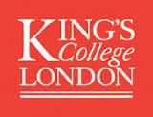

ESTAL (European State Aid Law) Lecture
Centre of European Law
The Dickson Poon School of Law

The Recent Cases of the CJEU on State Aid by Christopher Vadja QC, Judge, European Court of Justice

Mr. Justice Green, Royal Courts of Justice in the Chair

18.30 – 19.30
Monday 21 March 2016

The Edmond J Safra Lecture Theatre
Strand Campus
King’s College London

The lecture will be followed by a drinks reception

To reserve your place please click here

Enquiries to cel@kcl.ac.uk
http://www.kcl.ac.uk/cel
Follow us on Twitter @celkcl

