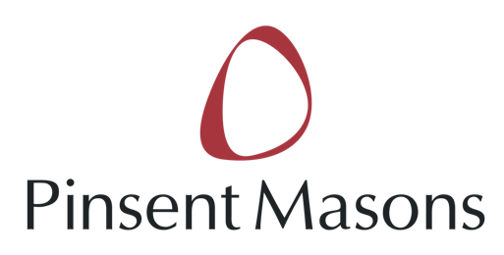

UK State Aid Law Association invites you to:

"A discussion on State aid and tax"

The UK State aid Law Association (UKSALA), in association with Pinsent Masons LLP, would like to invite you to a lecture on State Aid and Tax being held on Tuesday 24th September. Speakers for the evening are Paul Lasok QC (Monckton Chambers), Kelyn Bacon (Brick Court Chambers), Caroline Ramsay (Pinsent Masons), and the talks will include discussion of the EDF and British Aggregates cases.
Registration: 6.00 pm
Start: 6.30 pm
Finish and drinks: 7.30 pm
Venue: Pinsent Masons, 30 Crown Place, Earl Street, London, EC2A 4ES

Click here for a map of the venue.

RSVP – Jonathon.mcgovern@pinsentmasons.com

UKSALA is a new association of lawyers, academics, students, economists and others with an interest in State aid law. Its President is Judge Christopher Vajda, judge of the Court of Justice of the EU. UKSALA promotes education and knowledge in State aid law, by organising speaker events, preparing papers on State aid topics, engaging with UK and EU institutions responsible for State aid issues as well as maintaining a website with materials useful to State aid practitioners.

For details, and free membership, please visit www.uksala.org.

